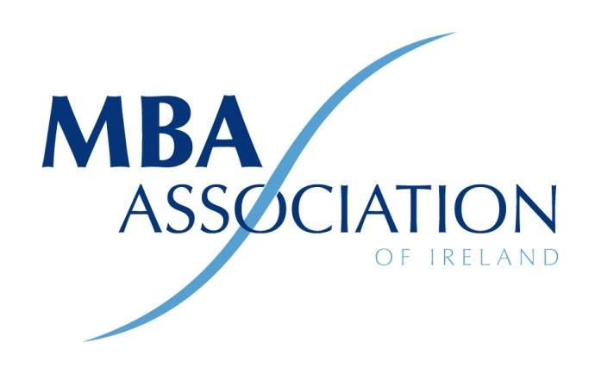

Minutes of 2023 AGM

The MBA Association of Ireland Ltd by Guarantee

Held at 18.00pm on Wednesday 25th January 2023
Guinness Enterprise Centre, Taylor's Lane, Liberties, Dublin
Present | By Proxy
1. Ronan Neary | - Michael Greene
2. Michael Bulman | - Brian Hamilton
3. Shane Connors | - David Cass
4. Conor Horgan | - Brian Murphy
5. Grace O’Shaughnessy | - Jerry Crowley
6. Greg Devlin | - Niall O’Donovan
7. Liam Fennelly | - Alacoque McMenamin
8. Robert Cooper | - Ronan Kearns
9. Emma Fagan | - Barbara Fitzgerald-Malone
- Gerard Kavanagh  - Declan Bourke | - Steven McIlhinney
 | - John O’Shaughnessy
 | - David Conway
- Barry-John Keating
- Michelle Gallagher
- Michael O’Grady
- Owen Murphy

Chair: Michael Bulman
Meeting Minutes: Ronan Neary
Michael Bulman welcomed everyone to the meeting. The president confirmed that a quorum had been reached. He then called the meeting to order.
Standing Orders
Ordinary Business
- Adoption of Standing Orders
Standing orders were adopted.
- Minutes of AGM 2022
Minutes of the 2022 meeting were read by Ronan Neary and approved without modification.
3 President's Report
The President confirmed that The MBA Association of Ireland (MBAAI) Company Limited by Guarantee (CLG) since 1st of December 2016.
The registered address is, Suite 59, Guinness Enterprise Centre, Taylor’s Lane, D08X5K3
Presidents Report
2022 has been an encouraging year for the association. We continued to see strong levels of interest from members as we transitioned back to more in person events post the worst of the COVID-19 pandemic. We were pleased to run a long and varied list of events for our members, including:
- “Leadership Reset – How to lead in an increasingly unpredictable world” with Ade McCormack
- “How Successful People Collaborate” with HBR Author Rob Cross
- Our always popular MBAAI Golf Event at Powerscourt
- “Better, Simpler Strategy” with Harvard Business School Professor Felix Oberholzer-Gee
- Our “Best Business Reads of 2021” Event for Christmas 2021 with Frank Dillon of Decision Magazine
- Our AGM and “New Ways of Working – An Employers Guide” with Kevin Callan of HR and employment law specialists Peninsula
- The “Meet the Entrepreneurs” evening in the Guinness Enterprise Centre
- Our South East chapter hosted a lunchtime webinar with Carolynn Chambers, CEO of the Good Governance Academy on Good Governance standards
- Our annual National Strategy Prize, with a talk from Stuart Crainer of Thinker’s 50 on the New World Order post COVID
- A Global Economic Outlook review with Goodbody
- Our annual Summer BBQ, as well as several social networking evenings during the year
- Our Southern Chapter hosted an event on Digital Transformation and Connected and Autonomous Vehicles with Johnson & Perrott Jaguar Land Rover
I would particularly like to highlight our National Strategy Competition, which returned to a face to face format this year and was won by the team from South East Technological University, in the face of some very stiff competition. This was a very successful event and we have had positive feedback from members, participants and the business schools involved, demonstrating that this key event in our calendar continues to be an excellent showcase for our talented MBA student population – the future of our organization. Events like this require many different contributors to make them happen, but I would particularly like to thank Michelle Gallagher and Bryan Murphy from the board who coordinated the planning and execution of the Strategy competition.
In addition to our own events, we continued our collaboration with the CGAI (Corporate Governance Association of Ireland) and the Professional Women’s Network (PWN). We also joined forces with Institute of Management Consultants & Advisors to offer each other’s events to our respective members.
We continued to build on the progress made with academic institutions with a view to building our future membership and, indeed, providing for the networking needs to many of our student members today with a view to securing our future with this cohort. Our Southern Chapter has been reinvigorated in 2022 with Jerry Crowley joining the board and driving events in the region which has been very welcome. We also built upon the foundations laid with our website in 2021, delivering event highlights and curated content to ensure this remains a valuable resource for our members.
In terms of looking back at performance for the past year, I am pleased to report that in the financial year from October 2021 to September 2022 we grew our membership by more than 15%, predominantly through increased numbers of student members. While this is very positive, we have seen our numbers of fully paying members stagnate somewhat and a big focus for the association in 2023 will be driving far greater levels of graduate membership from that student member population to strengthen the association into the future. To this end, we will be re-doubling our efforts this year on quality events, with additional investment in a calendar of strong speaker events and networking opportunities, as well as investing in additional resources to focus on retaining our current members and recruiting new full and graduate members.
As a board, we have managed our costs carefully in 2022 so that we achieved a surplus for the financial year. Our finance director will discuss this in more detail shortly, but I am pleased to be able to confirm that as a board we believe we can fund this additional investment in 2023 without an increasing our top line membership fees. However, to assist with funding this we will abolish the “direct debit discount” made available as a temporary measure some years ago to harmonise fees for all full members. We propose to make this change from 1st March 2023.
Our activities would not be possible without the support of our sponsors Decision Magazine, The Guinness Enterprise Centre, Davy Stockbrokers, Sia Partners and Goodbody, our supplier partners including Conor Horgan of Horgan PR & Marketing as well as Carmel Seery who maintains our accounts alongside our finance director.
The MBAAI is an association of MBAs run voluntarily by members and has no direct employees, so our volunteers’ efforts, and in particular those of our board of directors, shape our association and drive the value that we deliver to the wider membership. As such, special thanks must go to all board members who served over the last year. I would like to acknowledge the support and significant contribution of Niall O’Donovan who stood down during the reporting period, as well as Michael O’Grady, Ronan Neary and Grace O’Shaughnessy who step down from their roles in the coming weeks. As a board, we are always open to any full member who is interested in serving the association and we are grateful to all of those who have given so generously of their time and expertise to improve the association for our members.
Proposed: Conor Horgan Seconded: Greg Devlin
Secretary’s Report
Ronan Neary presented the Secretary’s report and outlined several changes to the membership of the Board which had occurred over the year.
Resignations
- Niall O’Donovan 18/08/2022
New Appointments
- Jerry Crowley 10/02/2022
- Grace O’Shaughnessy 10/02/2022
- David Conway 10/02/2022

Note: Mid-Western Chapter: Michelle Gallagher is Chairperson
Note: South-East Chapter: Michael O’Grady is Chairperson
Note: Eastern Chapter: is now run by the Board
Note Western Chapter: is now run by the Board
Note: Northern Chapter: is now run by the Board

Proposed: Owen Murphy Seconded: Liam Fennelly

Treasurer's Report

2022 Actuals
Income:
The total income for the year amounted to €58,404. This represented an increase of €2,850 since 2021, of which Business school membership accounted for €1,782.
Expenditure:
Total overheads for the year were €55,380. This was a total increased by €4,527 in the year. Seminar and event costs increased by €9,943, while IT costs reduced €4,221. The other cost headings are largely consistent with 2021 levels. Depreciation for the year amounted to €4,799.
The profit for the year amounted to €3,024.
Balance Sheet
The Bank Balance as at 30th September 2022 was €7,090. Trade debtors were €5,000 which was collected in full after the year end. Creditors has reduced by €6,912, largely due to the term loan repayments.
The net assets have increased to €18,761 at the year end.
Proposed: Gerard Kavanagh Seconded: Conor Horgan
Determination of Annual Subscriptions Fee
The direct debit discount will be abolished from 1st March 2023. This isn't a change in the subscription fees, but it does affect what members will pay.
Proposed: Conor Horgan Seconded: Greg Devlin
Election of Management Committee
Michelle Gallagher resigned her position and put herself forward for re-election.
Proposed: Grace O’Shaughnessy Seconded: Robert Cooper
Michael Bulman was re-elected as President. The reappointment of the retiring Executive Committee (Board) and Regional Committees was proposed and approved.
- President: Michael Bulman
- Company Secretary: Ronan Neary
- Finance Director: Shane Connors
- IT Director: Owen Murphy
- Academic Liaison Director: Michelle Gallagher
- Membership Director: Michael O’Grady
- Board Member: Bryan Murphy
- Board Member: David Conway
- Board Member: Grace O’Shaughnessy
- Board Member: Jerry Crowley

AOB
There being no further business the chairperson declared the meeting closed.

