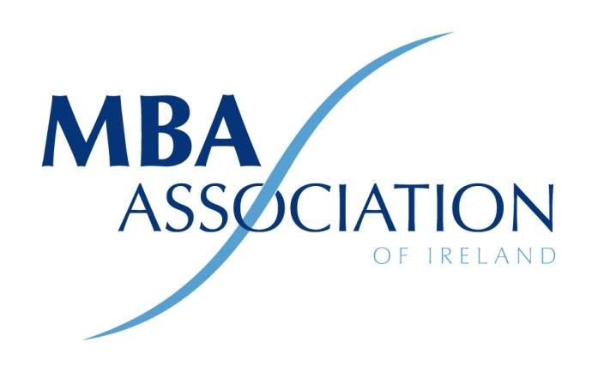

Minutes of 2021 AGM

The MBA Association of Ireland Ltd by Guarantee

Held at 18.30 pm on Monday 25th January 2021

Virtual via Zoom Platform-
Present:
- Alacoque McMenamin
- Ronan Kearns
- Ronan Neary
- Michelle Gallagher
- Michael Bulman
- Conor Horgan
- Niall O’Donovan
- Liam Fennelly
- Emma Fagan
- Gerard Kavanagh
- Michael Greene
- Michael O’Grady
- Brian Hamilton
- Eddie O’Sullivan
- Ian Walsh
- Mike Green
- Bridgette Murphy
- Catherine Butler Weir
- Myles Gardiner
- Greg Devlin
- Rex Coughlan
- John Byrne

By Proxy
- Patricia Ennis
- Estelle Fieldman
- Mona Shrestha
- Robert Cooper
- Maeve O’Connell
- Maureen Curtain

Noel Flynn, Accountant to the MBAII was not attendance.
Chair: Ronan Kearns
Meeting Minutes: Ronan Neary
Apologies: Mona Shrestha
Ronan Kearns welcomed everyone to the meeting and introduced the new members of Board. Apologies for Mona Shrestha for were recorded. The president confirmed that a quorum required for the AGM was 20 members and that it had been reached. He then called the meeting to order.
Standing Orders
Ordinary Business
- Adoption of Standing Orders
Standing orders were adopted for progressing with the meeting.
- Minutes of AGM 2020
Minutes of the 2020 meeting were read by Ronan Neary and approved without modification.
- 3 President's Report
The President confirmed that The MBA Association of Ireland (MBAAI) Company Limited by Guarantee (CLG)
since 1st of December 2016.
The registered address is,
Suite 59, Guinness Enterprise Centre, Taylor’s Lane, D08X5K3
Presidents Report
There were several changes to the Board this year:
Ronan Kearns stepped down as President but will remain on the Board until December 2021.
Michael Bulman will take on the role of President in January 2021 with Ronan Neary assuming the role as Vice President.
Mariola, our bookkeeper for 5 years, had stepped down and was replaced by Carmel. Mariola assisted us through the year and helped with the transition from the old website to the new website.
The Board now comprises of the following people:
- Ronan Kearns – President– MBA DIT
- Alacoque McMenamin – Advisory - MBA Fordham NY
- Ronan Neary – Company Secretary– MBA DIT
- Niall O’Donovan – Finance Director - MBA UCC
- Michael Bulman– Membership Director – MBA DCU
- Catherine Butler – Academic Liaison Director- - MBA Smurfit
- Mona Shrestha – Ordinary member – MBA Trinity
- Michael O’Grady – South East Chapter – MBA WIT
- Michelle Gallagher – Mid Western Chapter MBA UL

Ronan thanked all board members for their concerted effort over the last 12 months which had been a difficult year due to COVID-19 restrictions.
2020 was a challenging year for an organisation that prides itself on its ability to get its members networking. The year started off positive with the AGM held in January 2020. We had to cancel our March event, to be held in Lotto HQ and hosted by Ronan Neary. Since then, all events have been virtual.
Ronan highlighted how the board is continuously looking for new ways to maximise benefits to members by teaming up with the CGAI (Corporate Governance Association of Ireland) and the Professional Women’s Network (PWN). The MBAAI also joined forces with the Institute of Management Consultants & Advisors where we offered each other’s events to our respective members. In addition, members were invited to partake in a number of prestigious Thinkers 50 events.
Despite restrictions the MBAAI held 18 events from October 2019 to September 2020.
MBAAI biggest ‘event’ of the year was the completing of our new website that went live in November 2020. The board are very excited about our new website and look forward to working with an accurate and UpToDate database in 2021.
Some of the highlights of the year, where our Harvard Business Review speakers, Curtis Lefrandt and Megan Reitz who spoke on Innovation Capital and The Politics and Conversations at Work. We held our annual events with Davy on the Economic Outlook of Ireland and the Entrepreneurs evening with the Guinness Enterprise Centre. We also learned how to set up teams for success with Isolde Norris and how to adapt in a Crisis from David Cogg of Musgraves.
Ronan spoke how the Association will continue to delivery relevant content to our members through the Learning Zone on the new MBAAI website. We have lined up some exciting events for 2021 which will include such topics as Block Chain and Design Thinking. We will once again host Harvard Business Review Speakers. We will reschedule the Lotto event and hope to run the Schools Strategic Prize which we had to abandon last year.
Ronan thanked the MBAAI sponsors, Decision Magazine, The Guinness Enterprise Centre, Mason Hayes Curran, Davy Stockbrokers, Pathfinders and Deloitte our supplier partners including Conor Horgan of Horgan PR & Marketing.
Finally, Ronan thanked all directors who served in this year. And acknowledged the support and assistance offered by Alacoque McMenamin, Catherine Butler Weir and Niall O’Donovan who are stepping down from the board this year.
Secretary’s Report
Ronan Neary presented the Secretary’s report and outlined several changes to the membership of the Board which had occurred over the year.

Resignations
- Ray Ring - (19th January 2020)
- Barbara Fitzgerald Malone - (29th January 2020)

Vacant Positions
- IT Director
- Membership Director

Note: Mid-Western Chapter: Michelle Gallagher was been appointed Chairperson
Note: South-East Chapter: Michael O’Grady was been appointed Chairperson
Note: Eastern Chapter: is now run by the Board.
Note: Western Chapter: is now run by the Board.
Note: Northern Chapter: is now run by the Board.

Treasurer's Report

YOY Profit & Loss Comparative (2020 v 2019)
Income
- Membership Income reduced YOY by €3,314 which aligns to a reduction in paid members over the year – 29 members. Primary reasons are linked to Covid-19 pandemic:
- Schools fees increased YOY by €1,071. This was the first increase in 5 years. The revised fees applied from March 2020. Full effect will be recorded in 2021 financials. (Not a decision by the AGM – as not in the minutes)
- In summary, Income is down €2,402 in 2020 over 2019.
Expenditure:
- Events – significantly reduced costs, as in person events not allowed under Covid 19 restrictions. Last live event was the AGM in January 2020. Reduction of €7,860.
- IT Spend – lower in 2020 as funding was applied to the development of the new Website & Membership MS (capital expense). 2019 IT expenditure was high as old website needed support.
- Interest – a loan, in the amount of €14,000, was secured to fund the development of the new website. The interest rate is 4.4% per annum over 3 years. Balance at YE was €10,317.
- Depreciation – 6 months depreciation for the new Website developed was charged in 2020. The total outlay for the Website €23,995 – higher than the original quote of €20,606. Additional cost approved by the board.
Net Surplus for the year result - €4,104.
2021 Budget Overview
Income
- Membership – As an association we will target to maintain the fees level with 2020. Optimising the new website and scheduling key speakers for webinars are expected to improve this number in 2021.
- Budget Income in 2021 is targeted at €50,400.
Expenditure:
- Events – slightly higher than 2020, as speakers will be sought for online webinars, together with the anticipation that in person events may return by Summer 2021, pending latest restrictions.
- IT Spend - in 2021, we will seek to optimise our new website and functionality. The costs will cover GDPR Compliance, Hosting & Support.
- Depreciation – full year charge will be incurred.
In summary, the association is targeting a break-even Budget.
Balance Sheet Points:
- Fixed Assets: Website Development - €23,995 with 6 months depreciation, in the amount of €2,400.
- Cash Balance at year end was €13,632. School Fees are being collected presently (delay with remote work at Schools). These will sustain the association together with membership subs. Balance at bank today is €19,397.
- Reserves at year end are €11,242. 2020 profit of €4,104 increased reserve from 2019 balance of €7,138.
The adoption of
- Standing Orders
- Minutes of the AGM 2020
- Presidents Report
- Secretary’s Report
- Treasurer’s report

Proposed: Gerard Kavanagh Seconded: Catherine Butler Weir
Determination of Annual Subscriptions Fee
No change in Annual Subscriptions was proposed.
Election of Management Committee
Ronan Kearns, Alacoque McMenamin, Niall O’Donovan resigned their positions and put themselves forward for re-election.
Proposed: Michael Bulman Seconded: Conor Horgan
Michael Bulman was elected as President. The reappointment of the retiring Executive Committee (Board) and Regional Committees was proposed and approved.
- President: Michael Bulman
- Company Secretary (VP): Ronan Neary
- Operations Director: Ronan Kearns
- Finance Director: Niall O’Donovan
- IT Director: Vacant
- Academic Liaison Director: Michelle Gallagher
- Chair South Eastern Chapter: Michael O’Grady
- Board Member: Mona Shrestha
AOB
There being no further business the chairperson declared the meeting closed.

