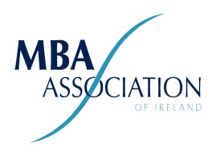

Annual General Meeting
of the MBA Association of Ireland (MBAAI) Limited
25th Jan 2021 (virtual).
AGENDA
1. Adoption of Standing Orders (President)
2. Minutes of AGM 2020 (Secretary)
3. President's Report (President)
4. Secretary’s Report (Secretary)
5. Treasurer's Report (Finance Director)
6. Appointment of Auditors (Finance Director)
7. Determination of Annual Subscription Fee (President)
8. Election of Board (President)
9. Any Other Business (President)

