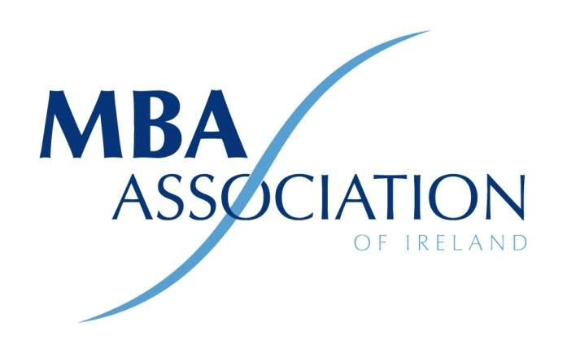

Minutes of 2022 AGM

The MBA Association of Ireland Ltd by Guarantee

Held at 18.30 pm on Wednesday 26th January 2021

Virtual via Zoom
Present:
- Alacoque McMenamin
- Ronan Kearns
- Ronan Neary
- Michelle Gallagher
- Michael Bulman
- Conor Horgan
- Niall O’Donovan
- Michael O’Grady
- Shane Connors
- Bryan Murphy
- Frank O’Beirne
- Grace O’Shaughnessy
- Jerry Crowley
- John O’Flaherty
- Martin O’Sullivan
- Liam Fennelly
- Emma Fagan
- Gerard Kavanagh
- Greg Devlin

By Proxy:
- Maeve O’Connell
- Aaron Walsh
- David Cass
- Declan Bourke
- Michelle O’Dwyer
- Robert Cooper
- Shirley Ryan

Chair: Michael Bulman
Meeting Minutes: Ronan Neary
Michael Bulman welcomed everyone to the meeting. The president confirmed that a quorum had been reached. He then called the meeting to order.
Standing Orders
Ordinary Business
- Adoption of Standing Orders
Standing orders were adopted.
- Minutes of AGM 2021
Minutes of the 2021 meeting were read by Ronan Neary and approved without modification.
3 President's Report
The President confirmed that The MBA Association of Ireland (MBAAI) Company Limited by Guarantee (CLG) since 1st of December 2016.
The registered address is, Suite 59, Guinness Enterprise Centre, Taylor’s Lane, D08X5K3
Presidents Report
Overall, 2021 has been an encouraging and exciting year for the association, albeit with a unique set of challenging circumstances driven by the COVID-19 pandemic. We held several interesting virtual events in 2020/21 including, Whistleblowing Policy with Grainne Madden, Cyber Security, and Internet Fraud, with Donal Murphy, Artificial Intelligence with Sia Partners and Blockchain with Dr Aidan Duane. We also hosted Harvard Business Review publishers Bill Sanders who spoke to us about Creative Conflict and Alex Lazarow on Innovation. We held our regular events on “Meeting the Entrepreneurs” with our partners from the Guinness Enterprise Centre the Economic Outlook with Davy Stockbrokers.

Michael highlighted the 2021 Strategy Competition, which was run virtually this year for the first time and won by the team from TU Dublin. This was a hugely successful event with a record number of teams competing. He thanked Michelle Gallagher who coordinated the planning and execution of this competition.

In addition to our own events, we continued our collaboration with the CGAI (Corporate Governance Association of Ireland) and the Professional Women’s Network (PWN). We also joined forces with the Institute of Management Consultants & Advisors and our welcomed to their events.
2021 saw a major re-focus on our relationships with academic institutions and we welcomed Munster Technological University as a new academic member in 2021.

This was our first full year since the launch of our new website and this has been a great success, offering a much-improved experience for our members and better tools for the board to understand the membership and manage the association.

Michael also reported on a slight growth in membership and the careful management of costs have resulted in a surplus for the financial year. The Board believes there is no reason to increase membership fees for the next twelve months.

Our activities would not be possible without the support of our sponsors Decision Magazine, The Guinness Enterprise Centre, Davy Stockbrokers, Sia Partners and Deloitte, our supply partners Conor Horgan and Carmel Seery.

The MBAAI is an association of MBAs run voluntarily by members and has no direct employees, so our volunteer’s efforts, shape the association and drive the value that is delivered to the wider membership. Special thanks must go to all board members who served over the last year. Michael acknowledged the contribution of Ronan Kearns, Mona Shrestha, Niall O’Donovan and Alacoque McMenamin who are stepping down.

Michael then took a moment to thank the members, on behalf of the board for their continued support and looked forward to continuing to serve the members in 2022.
Secretary’s Report
Ronan Neary presented the Secretary’s report and outlined several changes to the membership of the Board which had occurred over the year.

Resignations
- Catherine Butler Weir 01/05/2021
- Mona Shrestha 24/11/2021
- Ronan Kearns 24/11/2021
- Alacoque McMenamin 31/12/2021

New Appointments
- Owen Murphy 01/06/2021
- Bryan Murphy 01/06/2021
- Shane Connors 08/11/21

Note: Mid-Western Chapter: Michelle Gallagher Chairperson
Note: South-East Chapter: Michael O’Grady Chairperson
Note: Eastern Chapter: is now run by the Board.
Note: Western Chapter: is now run by the Board.
Note: Northern Chapter: is now run by the Board.

Treasurer's Report

2021 Actuals

Income:

An increase of €8k since 2020, Members fees had increased by €4, and Schools fees by 4k.
Expenditure:
Very similar to the previous year with the main increase in depreciation.
True Profit after adding back depreciation of Website is €9,183

Bank Balance: as at 30th September 2021 €11,152

Determination of Annual Subscriptions Fee
No change in Annual Subscriptions was proposed.
Election of Management Committee
Michael Bulman and Ronan Neary resigned their positions and put themselves forward for re-election.
Proposed: Gerard Kavanagh Seconded: Greg Devlin
Michael Bulman was re-elected as President. The reappointment of the retiring Executive Committee (Board) and Regional Committees was proposed and approved.
- President: Michael Bulman
- Company Secretary: Ronan Neary
- Finance Director: Niall O’Donovan /Shane Connors
- IT Director: Owen Murphy
- Academic Liaison Director: Michelle Gallagher
- Membership Director: Michael O’Grady
- Board Member: Bryan Murphy
AOB
There being no further business the chairperson declared the meeting closed.

