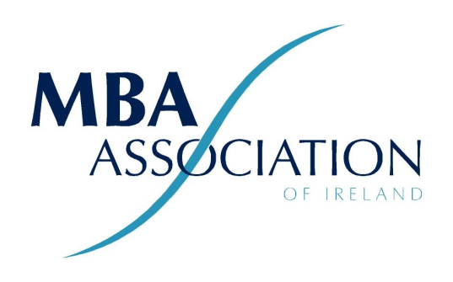

MBA Association of Ireland (MBAAI) Limited
held on 6.00 pm on Wednesday, 25th January 2023
in Guinness Enterprise Centre, Taylor's Lane,
Liberties, Dublin 8

I/We, .........................................................................................

Of ....

In the County of being a member of the above named Company (MBA Association of Ireland (MBAAI) Limited),

hereby appoint .......The President, MBA Association...............................................................

or failing him/her .......The Secretary, MBA Association.............................................................

or failing him/her, the Chairperson of the meeting

as my/our proxy to vote for me/us on my/our behalf at the Annual General Meeting of the Company to be held on 25th January 2023, and at any adjournment thereof.

Voting Instructions to Proxy (choice to be marked with an x)
Number or description of resolution | Favour | Abstain | Against
1. Adoption of Standing Orders | Yes
2. Minutes of AGM 2022 | Yes
3. President's Report | Yes
4. Secretary's Report | Yes
5. Treasurer's Report | Yes
6. Appointment of Auditors | Yes
7. Determination of Annual Subscription Fee | Yes
8. Election of Board
Unless otherwise instructed, the proxy will vote as s/he thinks fit.

Signed this ..................................day of ..........................

Signature ..........................................................................

Notes: Member signing proxy must be a paid up member of the Association

Completed proxies to be completed, signed and sent by PDF to president@mbaassociation.ie
or delivered to the Chairperson of AGM by 6.00 pm 25th January 2023.

